Name: Nooreldeen Ayman Mohammed Elmobashar
Track: Open Source
Branch: ITI Mansoura

______________________________________________________________________________

1. Create a user account with the following attribute
• username: islam
• Fullname/comment: Islam Askar
• Password:

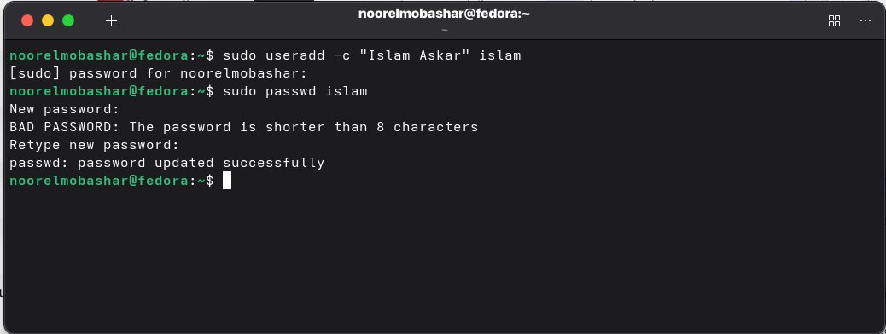
2. Create a user account with the following attribute
• Username: baduser
• Full name/comment: Bad User
• Password: baduser

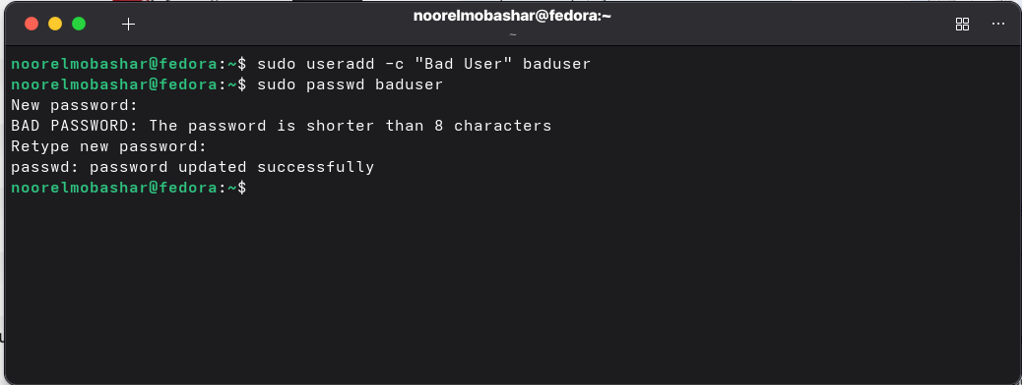

3. Create a supplementary (Secondary) group called pgroup with group ID of 30000
4. Create a supplementary group called badgroup
5. Add islam user to the pgroup group as a supplementary group
6. Modify the password of islam's account to password
7. Modify islam's account so the password expires after 30 days
8. Lock bad user account so he can't log in
9. Delete bad user account
10. Delete the supplementary group called badgroup.

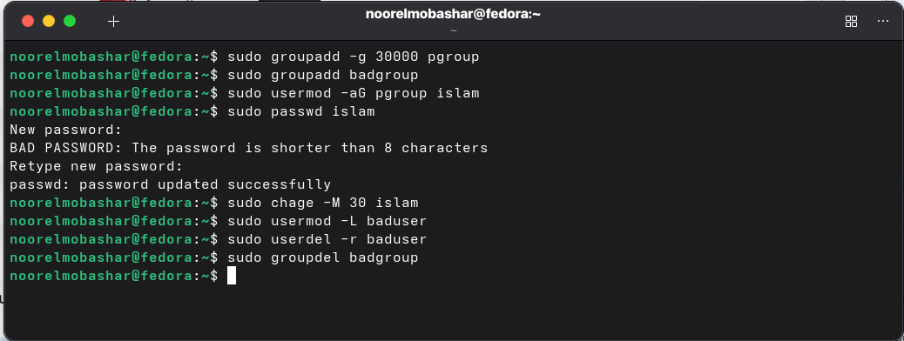

13. Create a folder called myteam in your home directory and change its permissions to
read only for the owner.
14. Log out and log in by another user
15. Try to access (by cd command) the folder (myteam)

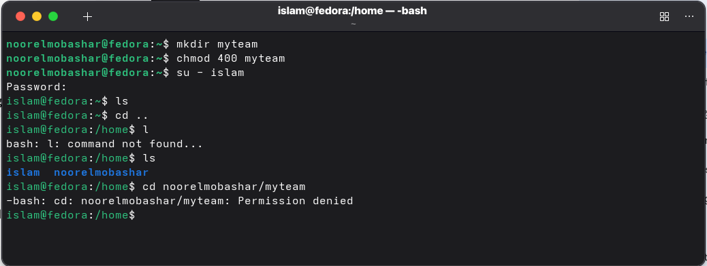

16. Using the command Line
• Change the permissions of oldpasswd file to give owner read and write
permissions and for group write and execute and execute only for the others
(using chmod in 2 different ways)
• Change your default permissions to be as above.

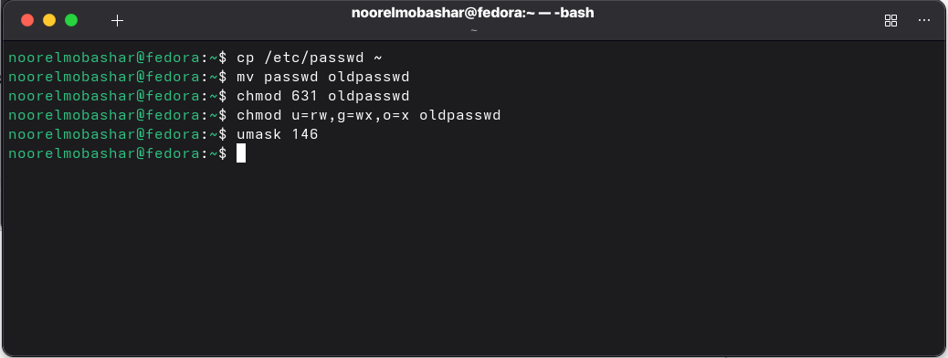

• What is the maximum permission a file can have, by default when it is just
created? And what is that for directory.

The maximum default is 666 for a file, as files are not created with execute permissions for security reasons. For Directories, the maximum is 777.

• Change your default permissions to be no permission to everyone then create a
directory and a file to verify

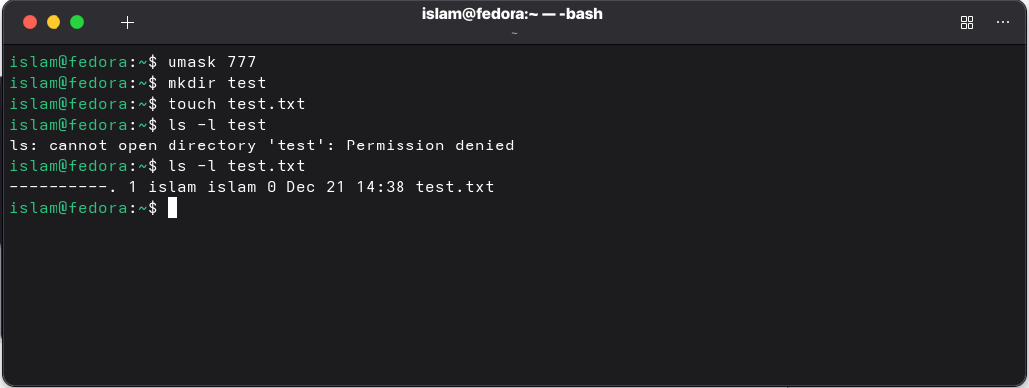

17. What are the minimum permission needed for:
• Copy a directory (permission for source directory and permissions for target
parent directory)
• Copy a file (permission for source file and and permission for target parent
directory)
• Delete a file
• Change to a directory
• List a directory content (ls command)
• View a file content (more/cat command)
• Modify a file content

Action | Source File/Dir Perms | Target/Parent Dir Perms
Copy Directory | Read (r) & Execute (x) | Write (w) & Execute (x)
Copy File | Read (r) | Write (w) & Execute (x)
Delete File | N/A (File perms irrelevant) | Write (w) & Execute (x)
Change Dir (cd) | Execute (x) | N/A
List Dir (ls) | Read (r) | Execute (x) (to see metadata)
View File | Read (r) | Execute (x) on parent dir
Modify File | Write (w) | Execute (x) on parent dir

18. Create a file with permission 444. Try to edit in it and to remove it? Note what
happened.
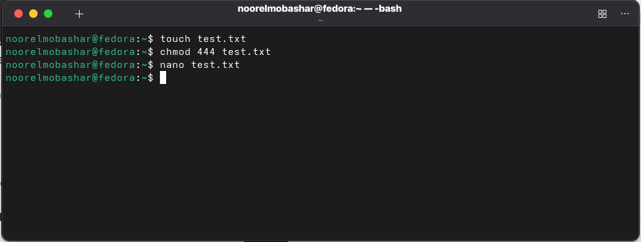
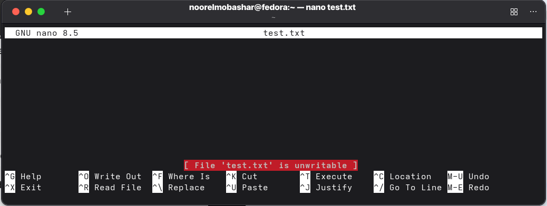
cant write in this file.

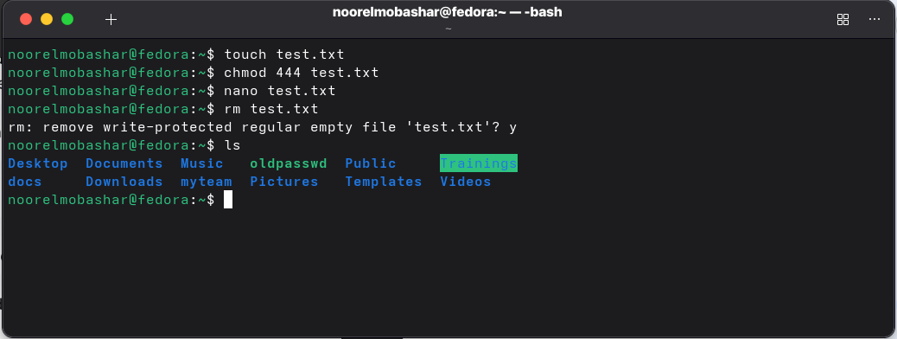
A confirmation to delete a write-protected file appeared.

19. What is the difference between the “x” permission for a file and for a
directory?

For a file it allows the OS to execute the file as a program.
For a Directory it allows you to enter or traverse the directory.

